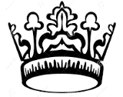 AP European History Rescue Pack Review

* Period: Renaissance & Reformation (1300-1600)
What is humanism?  Who is associated? | What is Northern Humanism?  Who is associated? | Explain the role of patrons in facilitating the art & learning of the era.  Please list 2 major patrons of the era.
Characteristics of Renaissance art:  Realism-  Perspective-  Individualism-  Themes- | Please identify one Renaissance work of art. Who was the artist and what is the significance of the work? | What is how does Castiglione define the “Renaissance Man” in The Courtier?  Pursue Avoid
Social Changes  Education:  Role of Women: | Machiavelli’s The Prince  (List at least 3 per column)  Rulers Should: Rulers Avoid: | Exploration  Motives?  Prince Henry the Navigator:  Vasco de Gama:  Hernando Cortes:  Bartolome de las Casas:

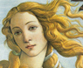
Please define or list the significance of the following:
Gutenberg-
Vernacular-
Secular-
Ferdinand & Isabella-
Erasmus-
Sir Thomas More-
Henry VII of England-
Wars of the Roses-
Henry VIII-
Elizabeth I-
Politique-
German Peasant Revolt (1525)- goal?
Miguel Cervantes-
Philip II of Spain-
Great Schism-
Pope Julius II-
Indulgences-
Simony-
Nepotism-
Theocracy-
Huguenot-
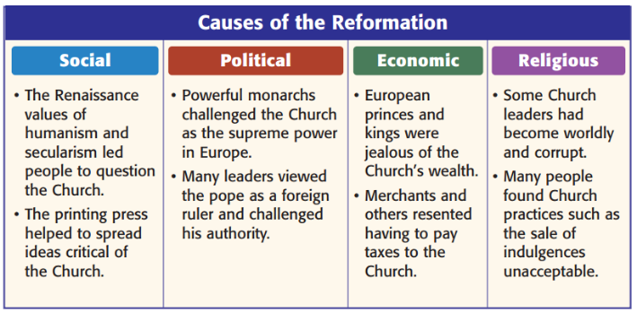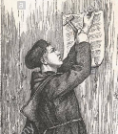
Explain in a short paragraph what prompted Martin Luther to post the 95 Theses.  Where & When? | Please list four differences between the Lutheran Church and the Catholic Church. | Beliefs of John Calvin  Where?  Predestination:  What are his followers not allowed to do? (List 4 lifestyle restrictions)
What is the goal of the Counter Reformation?  What was decided at the Council of Trent? | Why did Henry VIII break with the Catholic Church?  What are 3 beliefs of his Church of England?  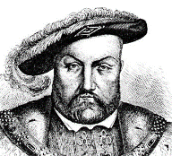 | What were the goals of Loyola’s Jesuit Order?
What are three characteristics of Mannerism?

Who was the most famous Mannerist artist?

Wars of Religion
Charles V  What problems (wars/religious strife) did Charles encounter?  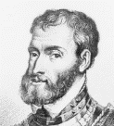  Peace of Augsburg*-  Why did & how did Charles divide his kingdom? | Please color and label all the areas ruled by Charles V & the Hapsburg family.  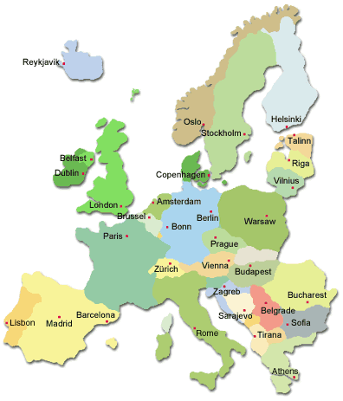
French Wars of Religion 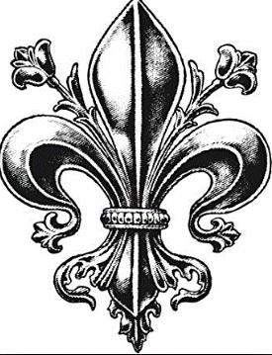  War of the 3 Henrys:  Valois Family Guise Family Bourbon Family  Why did people revolt against them? - Led by Henry, Duke of Guise - Strict Catholic - Supported by: - Led by Henry, Duke of Navarre - What faith and who supported?  Catherine de Medici- why was she unpopular?  St. Bartholomew’s Day Massacre:  Henry VI (formerly Henry of Navarre)- goals?  “Paris is worth a mass.”  Edict of Nantes: | Thirty Years War  Cause?  Defenestration of Prague-  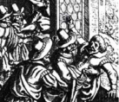  Why did France join the Thirty Years War?  Where was most of the destruction concentrated?  Peace of Westphalia*:

* Period: Absolutism & Constitutionalism (1600-1750)
Absolute Monarchy  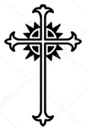 | Constitutional Monarchy  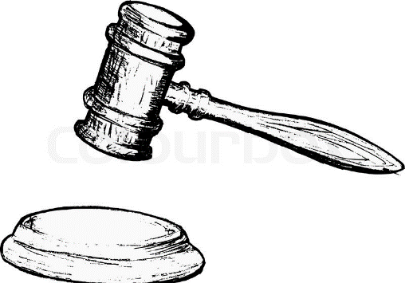
What do both systems have in common?

- Please define or list the significance of the following:
Divine Right Theory-
Mercantilism-
Habeas Corpus Act-
Petition of Right-
Parliamentarians/ “Roundheads”-
House of Lords-
House of Commons-
Cardinal Richelieu-
Jean Baptiste Colbert-
3 Absolutist Monarchs
Louis XIV  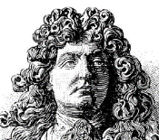 |  | Peter the Great  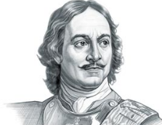 |  | Frederick the Great  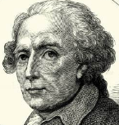
When/Where:  Accomplishments:  1. Built __________ Palace  2.  3.  4. |  | When/Where:  Accomplishments:  1. Westernization:  2. Port City?  3.  4. |  | When/Where:  Accomplishments:  1.  2.  3.  4.
Problems:  The Fronde-  Wars- |  | Problems: |  | Problems:
The Road to English Constitutionalism

Name | Accomplishments |  | Problems |  | Fate?
James I

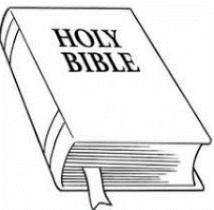

Charles I  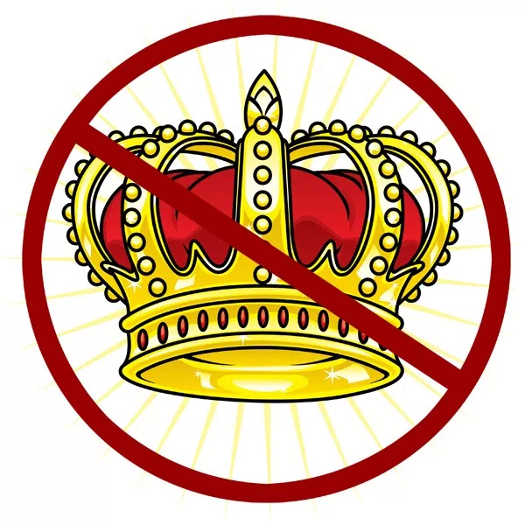 | Why did the Church & the aristocracy support him?
Charles II

James II

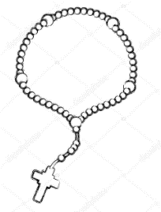
William & Mary
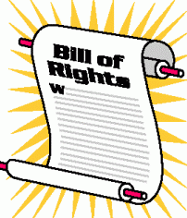

Why is the Glorious Revolution called “glorious”? | William & Mary had to agree to sign the English Bill of Rights, in exchange for power (1689). Please list five main provisions of this document.

What were three characteristics of Baroque art?
List two artists from this movement.

* Period: Scientific Revolution & Enlightenment (1500-1789)
What was the Geocentric view of the world?  How did the discovery of the New World unintentionally spark the Scientific Revolution?  What impact did the Catholic Church have on the Scientific Revolution? | Name the thinkers responsible for the following innovations:  - Microscope-  - Calculus-  - Modern telescope-  - Anatomy studies-  - Smallpox inoculation-  - Function of the heart-  - Elliptical path of planets-  - Scientific Method-

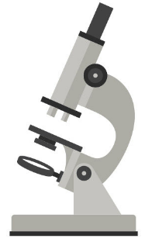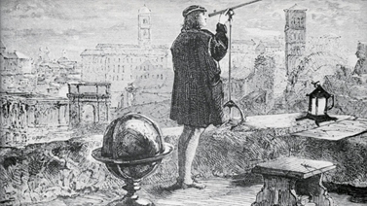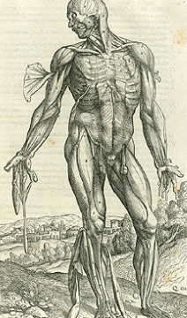
Natural Philosophers of the Scientific Revolution

Name | When & Where | Main Accomplishments
Copernicus

Brahe

Kepler

Galileo

Newton

Descartes

Agricultural Revolution
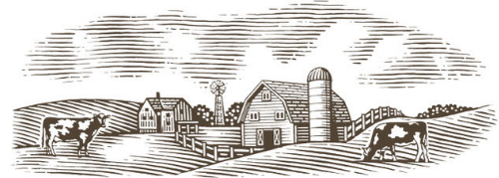
Please list three factors that led to increased food production in the 18th century. | What was invented by Jethro Tull and what impact did this machine have?
What products native to the Americas were fully incorporated into the European food supply by the 1700’s?  (hint: check out the Columbian Exchange) | What were “The Commons” and what role did this land play in traditional English life?  How did the Enclosure Acts impact the commoners?

The Dutch Golden Age
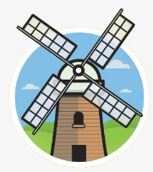
Why did The Netherlands rebel against Spanish authority in the 1500’s? | Describe the work of the master Dutch artists, including Rembrandt and Vermeer. (Subjects, composition)
What kind of government did the Dutch develop during the 1600’s?  What were their views on religious toleration & gender? | Dutch Economy  Industries Products

The Enlightenment
Social Contract Theory-

Thomas Hobbes’ Leviathan John Locke:

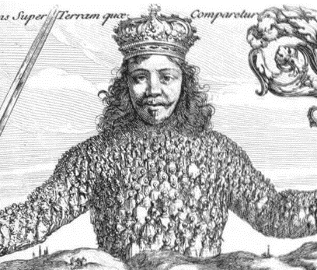

Please define the following:
Salons-
Philosophes-
Deism-
Enlightened Despotism-
Rococo Art- (list 3 characteristics)

Philosophers of The Enlightenment

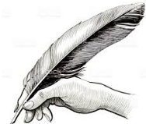

Name | When & Where | Main Theories & Accomplishments
Montesquieu

Rousseau

Voltaire
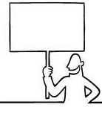
Adam Smith

Diderot

Mary Wollstonecraft
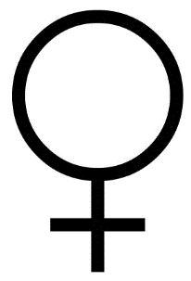

* Period: Ancien Regime & French Revolution (1700-1815)
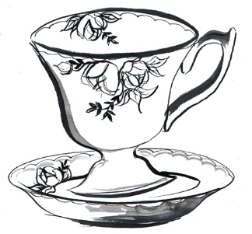
Please define or list the significance of the following:
Grand Tour-
Enlightened Despot-
Catherine the Great-
Maria Theresa-
Joseph II of Austria-
Junkers-
What ideals were important to the Enlightened Despots? How successful were they in incorporating reforms in their natio  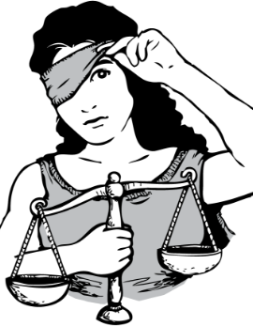 | Describe the causes & results of the Seven Years War. Why was it decisive for the colonial ambitions of Britain and France?  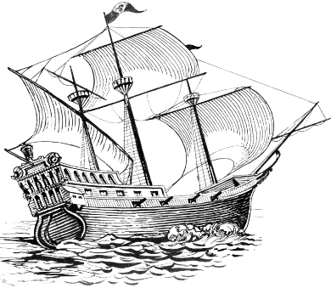
What was the lifestyle of the aristocracy of the Ancien Regime? (ex. food, work, Country estate life)  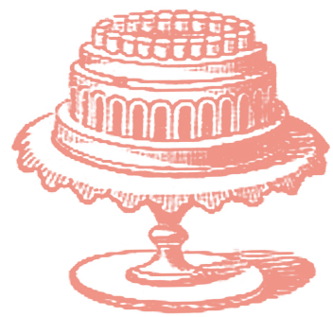 | Describe the food and work of the commoners of that era.  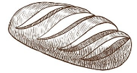

The French Revolution (1789-1815*)
*this depends on whether you see Napoleon as a child of the French Revolution, honestly.
First Estate | Second Estate | Third Estate
 |  | 98% of population
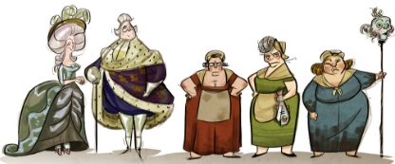 - List four economic and social problems led to the outbreak of the Revolution.

- How did the American Revolution and the Enlightenment inspire the people of France?

What was the Estates General and why was it unpopular with the 3rd Estate? | How did court life at Versailles contribute to the unpopularity of Louis and Marie Antoinette? What was their punishment?
What was the National Assembly and how was it formed? (hint: Tennis) | What were the three ideals of the French Revolution? How were these reflected in the Declaration of the Rights of Man?

How did Robespierre & the mobs of Paris corrupt the Revolution? What happened in Paris from 1792-1794?
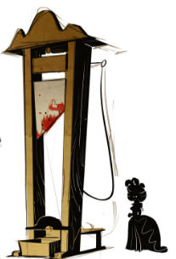
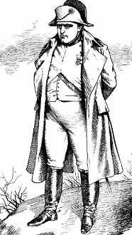
Napoleon (1799-1815*)
*With interruptions
How did Napoleon Bonaparte come to power?

Please highlight the countries controlled by France at the height of the Napoleonic Empire.  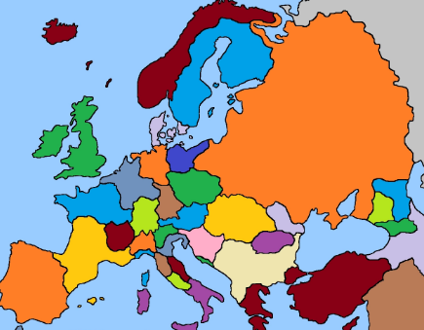  Napoleon controlled: (list) | How did Napoleon treat conquered armies and nations?  Why was Napoleon so popular with the people of France? (be specific)
Please share five provisions of the Napoleonic Code. | How did England react to Napoleonic expansion?  What is the Continental System, and why did Napoleon introduce it?

* Period: Age of Isms (1815-1848)
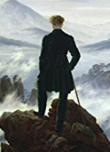
How did Napoleon finally fall from power?

What were the goals of the Congress of Vienna?

Leader?

- What was the Concert of Europe?

Types of Isms

Conservativism | Liberalism | Romanticism | Nationalism
Five ideals:  Leaders: | Five ideals:  Leaders: | Five ideals:  Artists: | Ideals:  Where do we see Nationalist movements in the early 1800’s?

- Please define or list the significance of the following:
- Classicism-

- Lord Byron-

- Percy & Mary Shelley-

- Pre-Raphaelite Art-

- Florence Nightingale-

- Queen Victoria-

- Socialism-

- Flora Tristan-
What was the cause of the Crimean War?  What lessons did Europe take from the war?  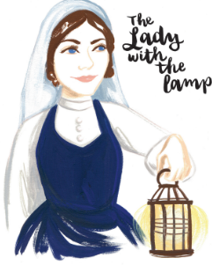 | How were the Revolutions of 1848 a test of the ideals of Conservativism?  What was the general result of the revolts?

* Period: Industrial Revolutions (1700-1914)
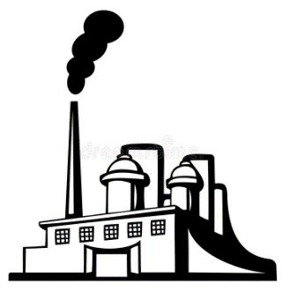
- Please define or list the significance of the following:
- Enclosure Acts-
- Capitalist-
- Chartist Movement-
- Luddites-
- Corn Laws-
- Tenements
- Unions-
- Strike-
- Great Exhibition-
- Thomas Malthus-
- Riccardo’s Iron Law of Wages-
- Utilitarians-
- Tariffs-
- William Gladstone-

 | 1st Industrial Revolution  (1700-1850) | 2nd Industrial Revolution  (1850-1914)
Standard of Living for Working Class
Methods of Production

Power Sources

Inventions

CCOT Practice- In a brief paragraph, describe continuities and changes during the First and Second Industrial Revolutions.

- Why was Karl Marx so angered and disillusioned by the Industrial Revolution?

- Please share eight ideas from Marx and Engels’ Communist Manifesto in the space below.

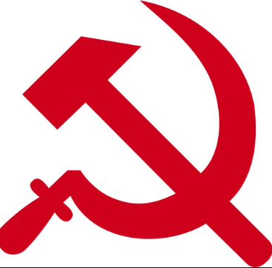
* Period: New Imperialism & Belle Époque (1848-1914)
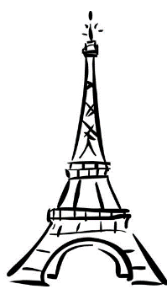
How did specifically did the rivalries of the late 1800’s contribute to the outbreak of World War I? (ex. African Scramble, unifications)

- Please define or list the significance of the following:
- Garibaldi-
- Camillo Cavour-
- Zollverein-
- Bismarck-
- Kipling’s White Man’s Burden poem-
- Benjamin Disraeli-
- Berlin Conference-
- Boer War-
- Moulin Rouge-
- Realism-
- Impressionism-
- Charles Darwin-
- Louis Pasteur-
- Joseph Lister-
- Paris Commune-
- Dreyfus Affair-
- Theodor Herzl-
- Eugenics-
- Pogroms-
How did Bismarck work to unify Germany through war? |  | What challenges did Bismarck face after unification?
What changes did Napoleon III bring to France? (Discuss at least 4) |  | How did Italy unify? What problems plagued Italy after unification?
What was the role of women in the late 1800’s? | Describe the work of the Pankhurst family. | What jobs were considered “White Collar” work? | What were four “preventative medicine” changes implemented by cities by 1900?
What products did Europeans seek from Asian & African colonies? | How were the Jewish populations mistreated in the late 1800’s? | Why were the Russians unhappy in the late 1800’s? | Why is the late 19th century referred to as the “Belle Époque”?

