Prompt: Evaluate the impact of smartphone technology on American society in the 21st century.

Source 1
An excerpt from a CNN news article, by John D. Sutter, September 2012

It took years for mobile-networking technology to develop and for cellular towers to go up. After mobile calls became more commonplace in a few developed countries, manufacturers added keyboards and larger screens, clearing the way for the SMS and mobile e-mail revolutions.

By the 2000s, a host of sensors -- from GPS, which enables mobile mapping, to accelerometers, which helps the phone know if it's being tilted -- were being squeezed into the gadgets. The mother of all smartphones, the Apple iPhone, debuted in 2007 with all these accouterments.

By then, phones had become the warehouse for technological innovation -- the Swiss Army knives of modern living, as many authors have argued. If you include tablets and e-readers in the mix, mobile devices have come to rival desktop computers and laptops for their usefulness in life and business.
"The reason why mobile technology is uniquely interesting to the world right now is because it represents the fifth wave of computing," Saylor said, with smartphones following Internet-enabled computing, desktops, minicomputers and early computer mainframes on the timeline. "And technology really is about what happens to the entire civilization of some several billion people or more when there is useful software running on the person and in the hand of everybody, every minute of the day."

Source 2
From a National Public Radio interview with author and psychologist Jean Twenge, April 2017.

For the first time, a generation of children is going through adolescence with smartphones ever-present. Jean Twenge, a professor of psychology at San Diego State University, has a name for these young people born between 1995 and 2012: "iGen."

She says members of this generation are physically safer than those who came before them. They drink less, they learn to drive later and they're holding off on having sex. But psychologically, she argues, they are far more vulnerable.

"It's not an exaggeration to describe iGen as being on the brink of the worst mental health crisis in decades," she writes in a story in The Atlantic, adapted from her forthcoming book. And she says it's largely because of smartphones…

[If] you look at the pattern of loneliness. It suddenly begins to increase around 2012. And the majority of Americans had a cell phone by the end of 2012, according to the Pew Center.

Given that using social media for more hours is linked to more loneliness, and that smartphones were used by the majority of Americans around 2012, and that's the same time loneliness increases, that's very suspicious. You can't absolutely prove causation, but by a bunch of different studies, there's this connection between spending a lot of time on social media and feeling lonely.

Source 3
Extract from an editorial in the Washington Post, by David Von Drehle. April 2018.

“As Obama put it in his electrifying 2004 address to the Democratic National Convention: “There is not a liberal America and a conservative America — there is the United States of America.” Riding that theme, he defeated the Democratic establishment on his way to the White House four years later, much as Trump flattened the Republican infrastructure while seizing the 2016 mantle.

It’s no mere coincidence that these are the first two presidents of the iPhone era. Introduced in 2007, the pocket supercomputer (and its competitors) placed the power of mass communication literally in the hands of millions of ordinary Americans, and the business of winning votes would never be the same. As different as Trump and Obama are, both candidates appreciated that the road to the presidency is now a communications autobahn, bypassing the antiquated Main Streets of the run-down political parties.”

Source 4
Political Cartoon from the Green Bay Press-Gazette, by Joel Heller, July 2013.
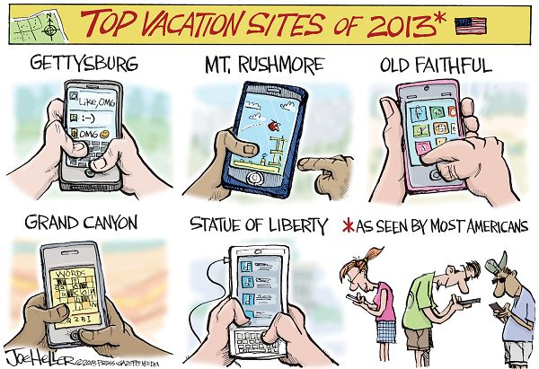

Source 5
Excerpt from the Nashville Times newspaper, by Casey Phillips, November 2014.

…the majority of Internet traffic (60 percent) now comes from mobile devices rather than desktops, which long served as the dominant online portal. And with search engines and digitally managed contact lists just a touch away, analysts say smartphones are affecting how the brain processes information.

The authors of a study published in the August 2011 issue of “Science” conclude that persistent access to information via search engines — Google, in particular, which fields more than 1 billion search queries per day — is changing how the brain catalogs knowledge. In a sense, the study authors conclude, Internet-connected devices such as smartphones have become a kind of “external memory source.”

“These results suggest that processes of human memory are adapting to the advent of new computing and communication technology,” the authors write. “We are becoming symbiotic with our computer tools, growing into interconnected systems that remember less by knowing information than by knowing where the information can be found.”

…As [punk vocalist/poet] Henry Rollins said not too long ago, ‘There’s no longer an excuse for stupidity.”

Source 6
Based on data collect by a Gallup survey of more than 15,000 smartphone users conducted April to May of 2015.
