“European Exploration & Discovery” – Document Packet

Document 1
I saw your Highnesses’ banners victoriously raised on the towers of the Alhambra, the citadel of that city [of Granada], and the Moorish king come out of the city gates and kiss the hands of your Highnesses [Ferdinand and Isabella]…And later in that same month, on the grounds of information I had given your royal Highnesses concerning the lands of India and a prince who is called the Great Khan—which means in Spanish ‘King of Kings’— and of his and his ancestors’ frequent and vain applications to Rome for men learned in the holy faith who should instruct them in it, your Highnesses decided to send me, Christopher Columbus, to see these parts of India and the princes and peoples of those lands and consider the best means for their conversion. For, by the neglect of the Popes to send instructors, many nations had fallen to idolatory and adopted doctrines of perdition, and your Highnesses as Catholic princes and devoted propagators of the holy Christian faith have always been enemies of the sect of Mahomet and of all idolatries and heresies.

Your Highnesses ordained that I should not go eastward by land in the usual manner but by the western way which no one about whom we have positive information has ever followed. Therefore having expelled all the Jews from your dominions in that same month of January, your Highnesses commanded me to go with an adequate fleet to those parts of India.
SOURCE: From the introduction to the journals of Cristofo Colon, First Voyage, 1492.

Document 2
Each Indian is to be given a house of his own for his family and a farm for cultivation and cattle raising. The Indians are to be persuaded to go about dressed like "reasonable" men. The Indians are to be persuaded to abandon their ancient evil ways, and they are not to bathe as frequently as before, as we are informed that it does them much harm.
SOURCE: Royal Decree of Ferdinand and Isabella, 1501.

Document 3
On the part of the king, sub duer of barbarous nations, we notify and make known to you as best we can that the Lord our God, living and eternal created the heaven and earth and one man and one woman, of whom you and we and all the men of the world were and are descendants, as well as all those who come after us.

We ask that..... you acknowledge the Christian church as the ruler and superior of the whole world, and as superiors that you agree to let the Christian priests preach to you.

If you do so, you will do well....we will receive you in love and charity .... and shall leave you free without slavery (The Priests) shall not compel you to become Christians unless you yourself wish to be converted.

But if you do not do this .... we shall forcefully enter into your country and shall make war against you .... we shall take you and your wives and your children and shall make slaves of them .... we protest that the death and losses which shall result from this are your fault.
SOURCE: Excerpts from a proclamation to be read in Spanish to Indians who were encountered. If the Indians did not agree to the terms, the Spanish considered them in defiance of the Spanish monarch, 1512.

Document 4
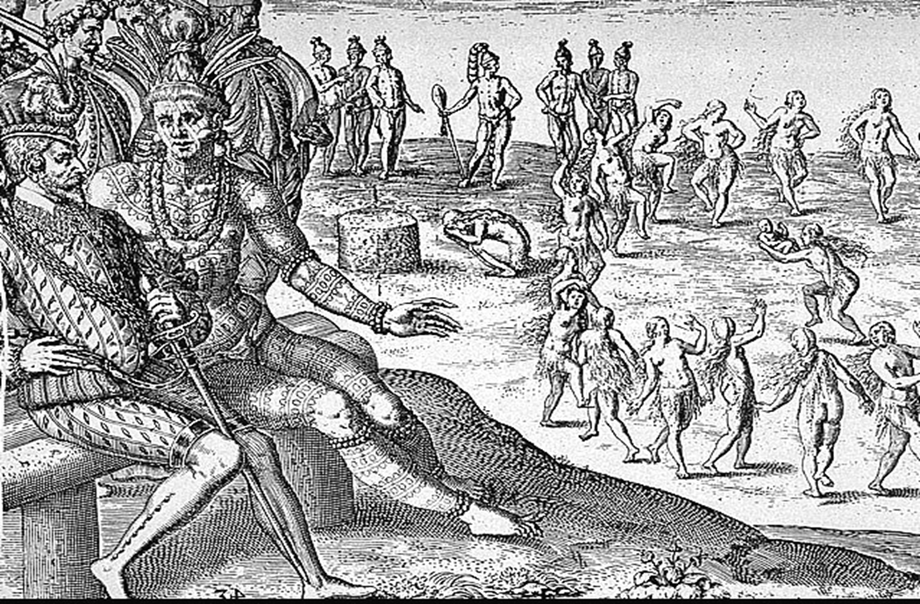
SOURCE: Theodore de Bry, “The Sacrifice of the Firstborn,” from his book, Historias de Las Indias, 1598.

Document 5
All the wars called conquests were and are most unjust and truly tyrannical. We have taken over all the kingdoms of New Spain. Our king, with all the power God gave him, cannot justify the wars and robberies against the Indians.

All the gold and silver, pearls and other riches, brought to Spain and traded among Spaniards in the New World-
-all is stolen, save perhaps a very little that came from the islands and places we have already depopulated. Those who stole it and today steal it by conquests cannot be saved unless they restore it.
The natives in any or all the areas we have invaded in the New World have acquired the right to make just war upon us and erase us from the face of the earth, and this right will last until the Day of Judgment.

By all reasoning, the Indians--who never harmed nor were subject to Christians--freely possess and rule their own lands, and no one can make just war upon them.

From the beginning until now, Spain's entire invasion of the New World has been wrong and tyrannical. And from 1510 on, no Spaniard there can claim good faith as an excuse for wars, discoveries, or the slave trade.
SOURCE: Bartolomeo de Las Casas, 1530s.

Document 6
God so loved the human race that He created man that he might participate, not only in the good that other creatures enjoy, but also in the capacity to seek the Supreme Good and behold it face to face. And since man, according to the testimony of the Sacred Scriptures, has been created to enjoy eternal life and happiness, which none may obtain save through faith in our Lord Jesus Christ, it is necessary that he should possess the nature which allows him to receive that faith. For in the office "Go ye, and teach all nations," He said all, without exception; for all are capable of receiving the doctrines of the faith. The enemy of the human race, the devil, who opposes all good deeds in order to bring men to destruction, invented a means never before heard of, by which he might hinder the preaching of God's word to the people. He inspired his followers to claim that the Indians should be treated as dumb brutes created for our service, pretending that they are incapable of receiving the Catholic faith.

We consider, however, that the Indians are truly men and that they are not only capable of understanding the Catholic faith but, according to our information, they desire to receive it. We declare that the Indians and all other people who may later be discovered by Christians are by no means to be deprived of their liberty or the possession of their property even though they be outside the faith of Jesus Christ. And that they may and should, freely and legally, enjoy their liberty and the possession of their property. Nor should they be in any way enslaved.

We define and declare that the said Indians and other peoples should be converted to the faith of Jesus Christ by preaching the word of God and by the example of good and holy living.
SOURCE: Papal Decree, 1537.

Document 7
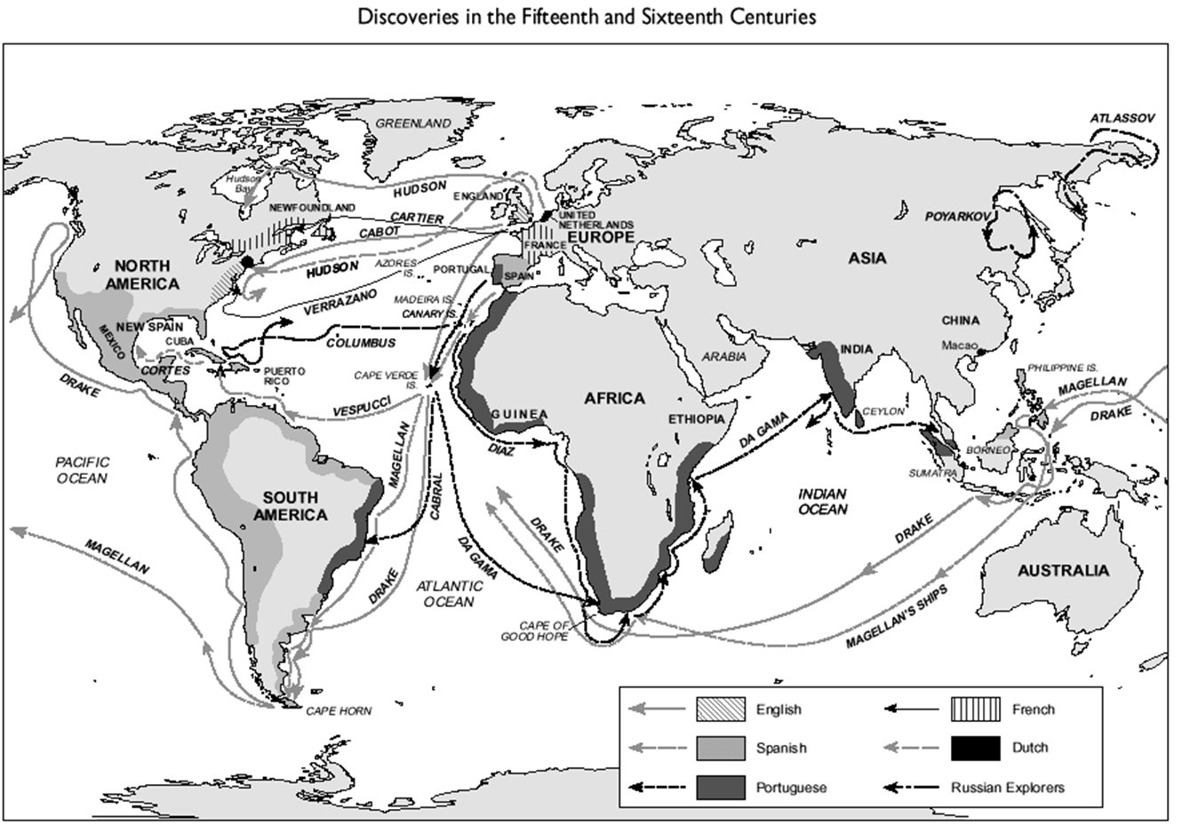
Document 8
During the 16c a truly global economy began to take shape as a consequence of the European encounters with the rest of the world. As the Europeans sailed the oceans of the world in search of profits, they pioneered a new form of economic organization—agrarian capitalism. In agrarian capitalism Europeans organized the production of certain kinds of commercial crops, such as sugar, tobacco, and indigo, which were raised for sale to an expanding population in Europe. With land expropriated from native peoples in the Atlantic islands, the Americas, and parts of Asia, European capitalists relied on slave labor, mostly provided by transplanted Africans.

Agrarian capitalism depended on the creation of European empires—the settler colonies, plantation colonies, and trading post empires of the Portuguese, Spanish, Dutch, French, English, and Russians. These empires, however, were very different from those of the ancient world, medieval Europe, pre-conquest Americas, and Asia. In ancient Rome, medieval Byzantium, and early modern China, for example, imperial government promoted monopolies and inhibited free access to the market and thus stymied the development of capitalism.
These empires produced economic stagnation instead of growth. But in the European global empires of the 16c, the organization of trade and the division of labor took place outside the authority of any one state, a fact that made it impossible for a single government to monopolize completely economic resources. It was the competition among imperialist states, rather than control by a single powerful empire, that was new.

The creation of the European empires during the 16c made it possible for capitalists to maximize their profits through regional specialization. Western Europe became the core of the global economy, the center of a complex variety of economic activities and institutions—banking, insurance, trade companies, gun manufacture, shipbuilding, and the production of cloth. In Europe agriculture was more and more devoted exclusively to producing food, and the labor supply was free—neither serfs, as had been the case in the Middle Ages, nor slaves, as was the case in parts of the Americas. The distant colonies, especially in Spanish and Portuguese America, became the periphery devoted to raising single cash crops, such as sugar, tobacco, cotton, coffee, or indigo for dyes. Agriculture in the periphery was produced on large estates by slaves.
The capitalist global economy has steadily and relentlessly expanded throughout the world since the 16 c. Much of the subsequent history of Western civilization can be understood only in terms of the triumph of capitalism and the economic integration of a world dominated by Westerners. The capitalist global economy has yielded many benefits in enhancing the material well-being of the middle classes of the West, increasing the available food supply of the world, and stimulating technological innovation. But there have been costs. Since the 16c, the gap between rich and poor individuals and rich and poor countries has widened, and societies on the agrarian periphery have found it enormously difficult to break out of their disadvantaged position in the world economy.
SECONDARY SOURCE: The West: Encounters and Transformations. Brian Levack, et. al., New York: Pearson/Longman, 2004, pp. 420-421.

