Name_______________________________________________

Physical Features Map

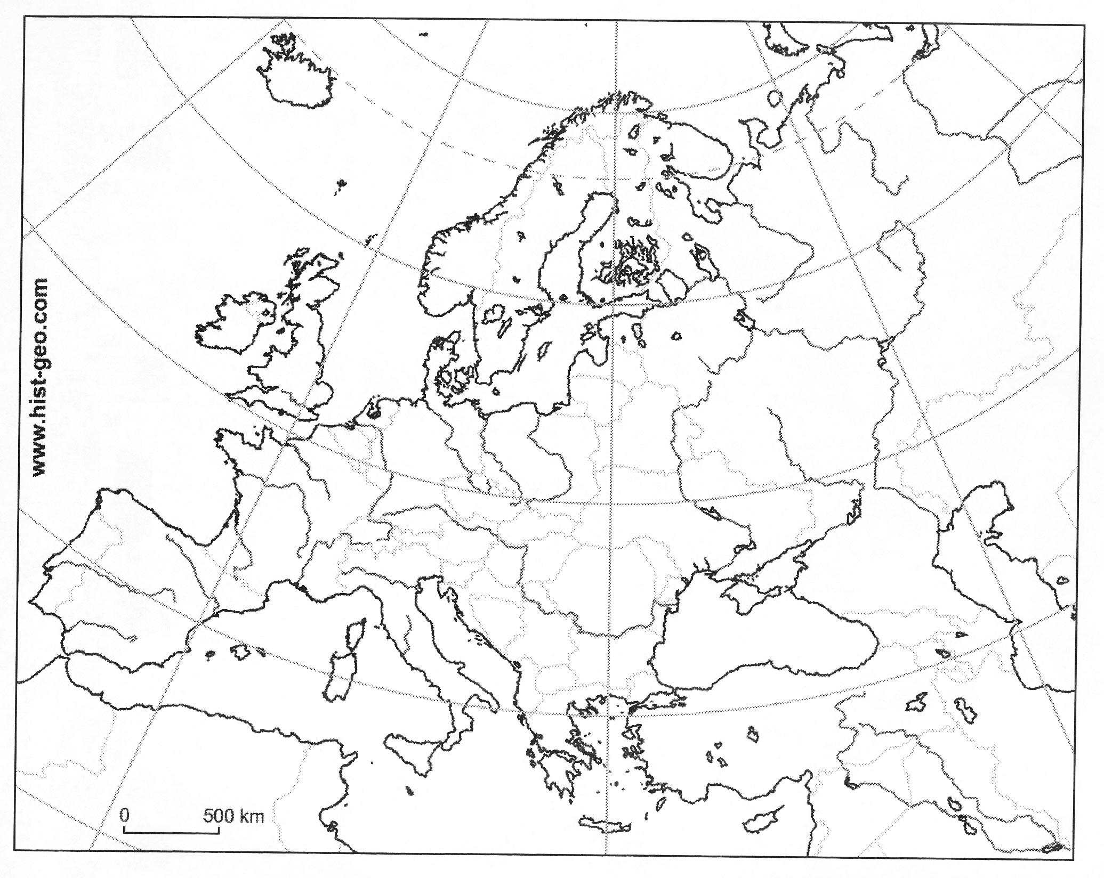

Modern Political Map

